**Experiment 1.2**

**Student Name:** Gaurav Kumar**UID:** 22MCC20177

**Branch:**MCA CC & Devops**Section/Group:** 22MCD-1-A Group

**Semester:**2**Date of Performance:** 01-03-2023

**Subject Name:** Cloud Computing Lab**Subject Code:** 22CAP-687

**Aim/Overview of the practical:**

Create Web App in Azure and publish using File Exp

**Task to be done**

To create a Web App in the Azure and then publish that web App using the File Explorer.

**Code/Steps for the Practical :**

**STEP 1)** Log in to the Azure portal (https://portal.azure.com).

**STEP 2)** Click on "Create a resource" from the left-hand menu and search for "Web App" in the search bar.

**STEP 3)** Select "Web App" from the search results and click on "Create" to start the creation process.

**STEP 4)** In the "Basics" tab, fill in the required fields such as subscription, resource group, and app name. Choose the runtime stack, operating system, and region that you want to use.

**STEP 5)** Click on the "Next: Monitoring" button to go to the next tab. Here, you can configure application insights if you want to monitor your app's performance.

**STEP 6)** Click on the "Next: Tags" button to go to the next tab. Here, you can add any tags that you want to apply to the resource.

**STEP 7)** Click on the "Review + create" button to review the settings you've entered. If everything looks good, click on the "Create" button to create the web app.

**STEP 8)** Once the web app is created, go to the "Overview" tab and click on the "Get publish profile" button to download the publish profile for the web app.

**STEP 9)** Open File Explorer and navigate to the folder where you want to publish your web app.

**STEP 10)** Right-click on the folder and select "Add Network Location".

**STEP 11)** In the "Add Network Location" wizard, select "Choose a custom network location" and click "Next".

**STEP 12)** Enter the URL of your web app's FTP server (ftp://<app-name>.ftp.azurewebsites.windows.net) and click "Next".

**STEP 13)** Enter the credentials from the publish profile that you downloaded earlier and click "Next".

**STEP 14)** Give the network location a name and click "Next" and then "Finish".

**STEP 15)** Now you can copy your web app's files to the network location that you just created using File Explorer.

**STEP 16)** Once the files are copied, open a browser and navigate to your web app's URL (https://.azurewebsites.net) to see your published web app.

**Output:**

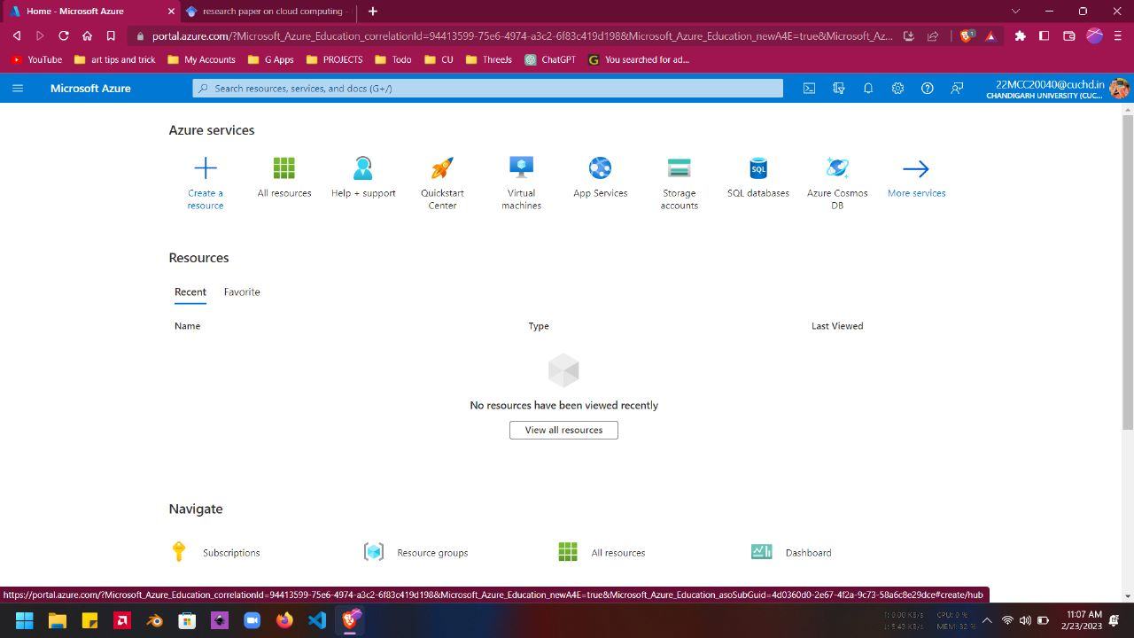

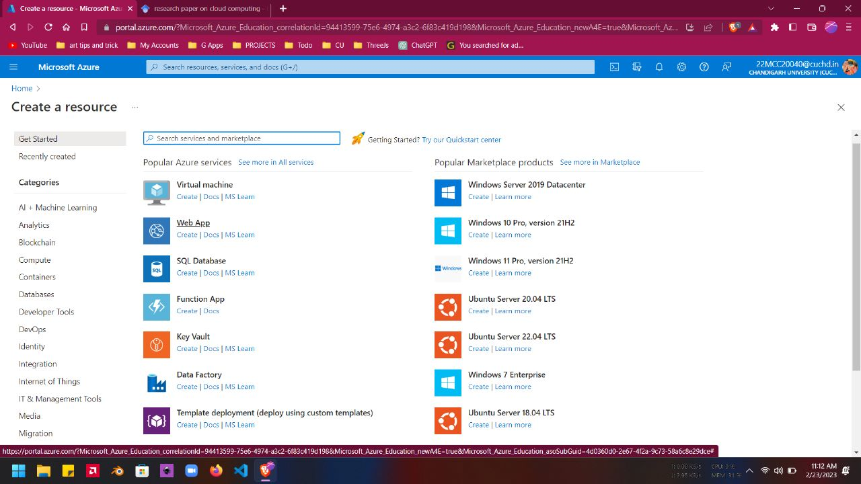

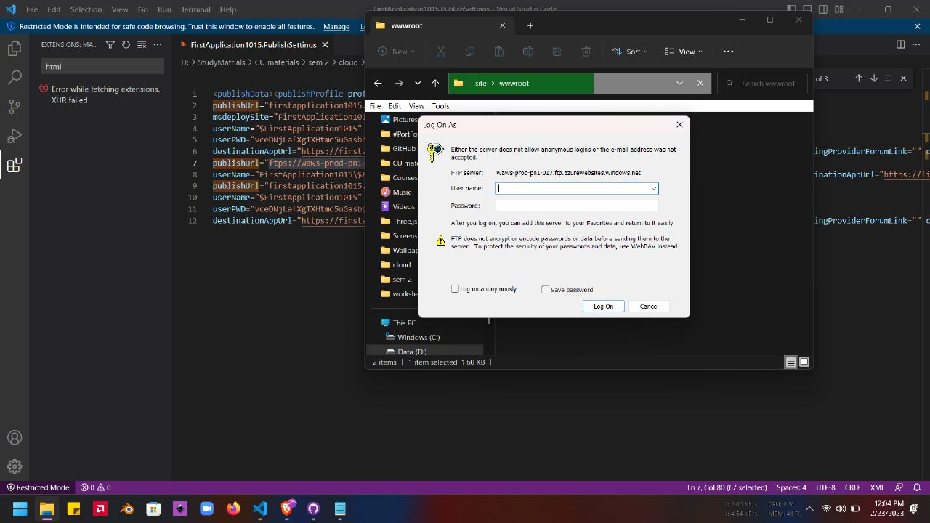

**Learning Outcomes (What I have learned)**

* I Learned to: -
  + - * Create resource in the azure portal
      * To deploy the web app on the azure portal

**Evaluation Grid:**

|  |  |  |  |
| --- | --- | --- | --- |
| Sr. No. | Parameters | Marks Obtained | Maximum Marks |
| 1. | Demonstration and Performance  (Quiz) |  | 22 |
| 2. | Worksheet |  | 8 |